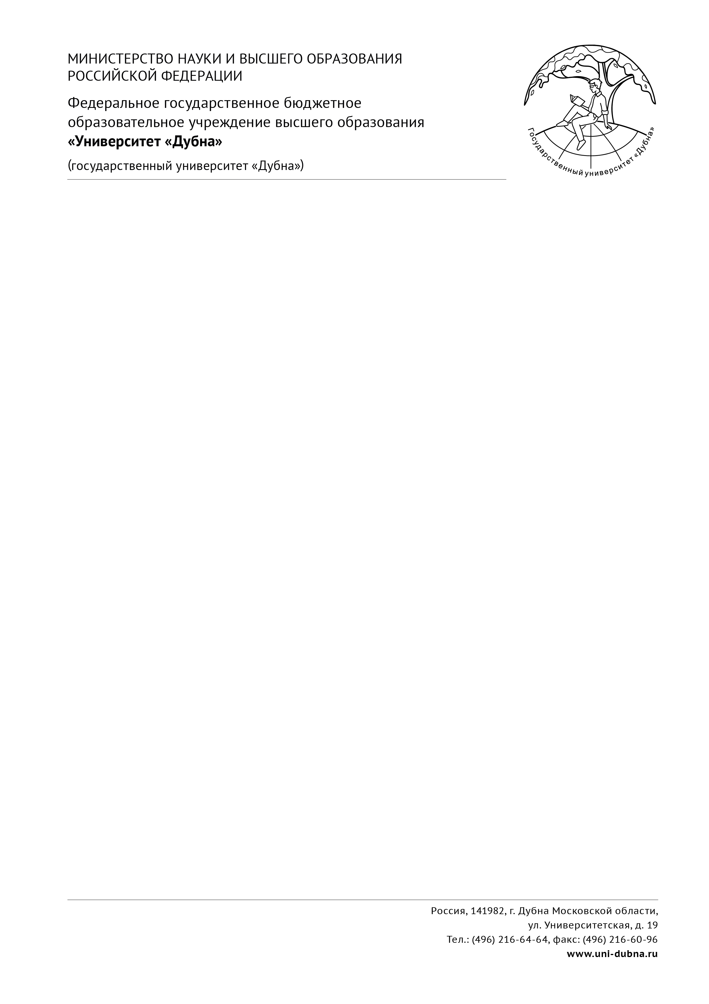

__________________ №______________
На №_________________от___________

